WASHINGTON PARISH COUNCIL MEETING

Draft MINUTES of the monthly meeting of Washington Parish Council held on Monday 2nd March 2026 in the Washington Village Hall (Doré Room) School Lane, Washington RH20 4AP

Members Summoned and Present: Cllr C. Brookes, Cllr A. Dillaway, Cllr B. Hanvey, Cllr T. Keech (Vice-Chairman) and Cllr J. Thomas.

Absent: Cllr A. Lisher (Chairman) and Cllr O. Jupp

In Attendance: Cllr P Marshall (WSCC), Cllr E Beard (HDC), Cllr J Grech (HDC) and Cllr C. Fisher (HDC). No Members of the Public or Press.

Officer’s Present: Ms Z Savill (Clerk to the Council).

The Vice-Chairman opened the meeting at 7:30pm in the absence of Cllr Lisher (Chairman)

FC/26/03/01 Apologies for Absence
The Council RESOLVED to receive and accept apologies from Cllr Jupp and Cllr Lisher

FC/26/03/02 Declaration of Members’ Interests and Dispensations.
Cllr Keech (Vice-Chairman) declared a disclosable interest in Agenda item FC/26/03/07 because he is a trustee of the Annie Bertha Lloyd Trust.

The Council RESOLVED to AGREE a dispensation for Cllr Keech to provide information for this item because it is in the interests of the local community (Standing Orders 13, I ((ii),) and then to leave the meeting prior to voting.

FC/26/03/03 Minutes of the last Full Council meeting
The Council RESOLVED to ADOPT he Draft Minutes of the Full Council Meeting held on 2nd February 2026 to be duly signed by the Vice-Chairman.

FC/26/03/04 Public Forum
There were no spoken or written representations to report from the public.

FC/26/03/05 County and District Council Reports

County Council Reports
Cllr Marshall reported the following:

  - A Government decision on potential unitary reorganisation in West Sussex is expected before the end of March; the Sussex Strategic Authority has been
legally established, with its first mayoral election planned for 2028.

  - WSCC approved a balanced £2.3bn 2026/27 budget without service cuts or reserve use or, as with some local authorities, applying for emergency loans
from central government; £30m will be lost over three years following the Fairer
Funding Review.

  - Residents have not yet responded to an invitation via Cllr Beard (HDC) to discuss
traffic issues on the Old London Road with Cllr Marshall. A resident who has written to the Council requesting double yellow lines, has been referred to
Cllr Marshall.

Horsham District Council Reports

Cllr Fisher reported the following:

  - There are delays to the roll-out of household food-waste collections; expected mid-April in some areas.

  - Councillors have urged HDC to prioritise CIL funding for leisure/wellbeing projects in the south of the district. A decision on the allocation for the district is expected by April.

  - National powers restricting pavement parking expected.

  - Complaints about alleged noise, dust and late working hours at Barnard’s Nursery in Rock Road (Washington parish) are under investigation; If a related planning proposal at the site is recommended for approval, Councillors will request it is “called in”

  - Thakeham Tiles Ltd proposal for 108 dwellings on the Rock Road site (neighbouring Thakeham parish) will be decided at the HDC Planning Committee on 17th March; concerns remain over impact on local infrastructure and road safety for nearby schools, loss of employment and distribution of CIL funds. PC urged to notify HDC this week if it wants to make spoken representations regarding its strong objection to the application.

- Concerns raised by Cllr Hanvey that Washington PC was not consulted on the naming of
Storrington Grove care home; the matter would be discussed later in the meeting and
reported to Cllr Fisher to take up with HDC.

The County and District Councillors left the meeting.

FC/26/03/06 Planning applications, Decisions, Appeals and Compliance Matters
The Council discussed the following planning applications in the parish:

DC/26/0238 – The Clearing Rock Road Storrington West Sussex
Fell 1 x Silver Birch
The Council RESOLVED to make NO OBJECTION to the application.

Planning decisions
DC/25/1839 - Storrington Grove Care Home Storrington Road Pulborough RH20 4A
Description: Installation of 1x non-illuminated 'V' shaped entrance sign, 1x illuminated single sided post mounted entrance sign, 1xilluminated wall mounted entrance sign and 1x non-illuminated set of individual letters.

The Council noted the decision on 11th February 2026 by HDC to approve the planning application.

Appeals
None reported.

Compliance Cases
The Council noted that HDC’s planning compliance team had opened an enforcement
investigation reference EN/26/0062 18/02/2026 into “allegations of noise, dust, burning and
general disturbance being caused by construction works on the site” at Barnards Nursery,
Rock Road, Washington.

FC/26/03/07 Written Motions
The Council RESOLVED to agree procedural motion (Standing Orders 10a 9vi)) that
Cllr Lisher’s Written Motion (Appendix A) is moved to the end of the meeting. REASON: so
that the Vice-Chairman can leave the room in accordance with the terms of his dispensation
(Min Ref: FC/26/03/02) without missing other Council business for transaction.

FC/26/03/08 Grant applications
The Council received and reviewed a grant application (Appendix B) from the 4-Sight Charity
towards its supporting its operations. It was noted that currently there are 7 residents in the
parish who benefit from the charity’s services.

Following a discussion, the Council RESOLVED to support in principle to award a grant of £250
under the Local Government Act 1972 Section 137, subject to eligibility. Delegation powers
awarded to Clerk to clarify and decide on the award to be ratified at the next meeting.

FC/26/03/09 Clerk’s Report
The Council received and noted the Clerk’s report (Appendix C) and correspondence
previously circulated.

The following actions on additional matters arising since the last FC meeting were agreed :

FC/26/02/11: Council to write to HDC objecting to lack of consultation on the naming
of Storrington Grove Care Home.

FC/26/01/14 Under the Council’s banking mandate, only a Full Power Signatory can
apply for the Lloyd’s credit card; Clerk to liaise with Cllr Keech.

FC/26/02/10: Clerk to prioritise the Council’s application to register the village pub
with HDC as an Asset of Community Value.

FC/26/03/09: Sussex Local Spring editorial from the Chairman
Approved with no amendments.

FC/26/03/10 Reports from representatives of Outside Bodes
The Council discussed and noted the following reports (Appendix D):

- Written report from Cllr Dillaway on HDC’s meeting with Parishes 17th February.
- Written report from Cllr Lisher on the WSALC Forum for Chairs on
24th February 2026.
- Written report from Cllr Thomas on HALC meeting on 25th February 2026.

FC/26/03/11 Storrington & Sullington and Washington Neighbourhood Plan
There were no further updates reported.

FC/26/03/12 Urgent matters
To Receive and review any urgent matters in accordance with the Council’s Standing Orders.

DC/25/2087- Thakeham Tiles, Rock Road – Outline application for up to 108
dwellings:
The Council reviewed Cllr Fisher’s advice earlier in the meeting to contact HDC as
soon as possible if it wants to make spoken representations on the application at
the next HDC Planning Committee meeting later this month.

Following a discussion, the Council RESOLVED that it had nothing further to add to
its previously submitted comments of strong objection to the application.

FC/26/03/13 Financial
The Council RESOLVED to approve the amended schedule of payments (Appendix E)
for invoices totalling £5,146.64; to note receipts (Appendix F) totalling £672.51 and
reconciliation of all bank accounts (Appendix G) for the total balance of £141,677.58 since the
last meeting.

FC/26/03/14 Chairman’s announcements
None reported.

A member of the public entered and left the room.

FC/26/03/15 Dates and Times of the next meetings
The Council noted the following meeting dates:
Planning & Transport Committee: Monday 16th March 2026 at 7:00pm
OSRA Committee: Monday 16th March at 7:45pm
Annual Parish Meetings Monday 13th April 2026 7:00pm followed by Full Council at 7:30pm
Personnel Committee Meeting: for annual staff appraisal and salary review. To be confirmed

The Clerk reminded Chairmen to prepare annual reports for the Annual Parish Meeting for
distribution with the agenda 7 clear days beforehand.

FC/26/03/16 Co-option
There were no applications received for the four Councillor vacancies.

FC/26/03/17 Confidential Session
The Council RESOLVED that under the Public Bodies (Admissions to Meetings) Act 1960, the
public and press be excluded from the meeting for the next two items of confidential business.

FC/26/03/18 Washington Recreation Ground Charity: Rampion 2 legal matters
The Council noted that there had been no further update on its request for amendments to
Rampion’s Heads of Terms for cable route access on the Washington Recreation Ground.
Deferred to the next meeting.

FC/26/03/19 Staff Matter
The matter was discussed.

The public part of the meeting was reconvened.

FC/26/03/20 Written Motion
The Council received and reviewed a written motion (Appendix A) from the Chairman and
seconded by Cllr Dillaway to support in principle, the Annie Bertha Lloyd Trust’s early
exploration of building four or five single-person maisonettes at their alms cottages in
Washington.

Cllr Keech (Trustee) outlined the proposals and the possibility of using local S106
affordable housing funds from the parish. He explained that HDC has indicated the
development would be a good use of the funds, subject to planning permissions. He
then left the meeting before discussion and voting, in accordance with his
dispensation under Min Ref: FC26/03/02.

Following the Clerk’s advice, sought from the Neighbourhood Plan’s Consultant, the
Council RESOLVED to agree the motion as amended by Cllr Dillaway to the following:

The Parish Council, while reserving its right to object later, is willing in principle to
support the Charity’s exploration of this site, subject to compliance with relevant
policies of the Neighbourhood Plan and Local Plans for Horsham District and the
SDNPA and evidence of genuine local housing need.
Further debate will take place upon receipt of a detailed proposal.
There being no further business to transact, the meeting ended at 9:15pm.

Signed………………………………………..

Dated…………………………………………

Appendix A
Written Motion for agenda item FC/26/03/20

Appendix B
Grant application FC/26/03/08

Appendix C

Report to: Washington Parish Council

Title: Clerk’s Report

Date: 24th February 2026

Meeting Full Council 2nd February 2026

Contact Officer: Clerk to the Council

The Clerk reports the following actions and updates from previous minutes:

Minute Reference | Actions | Update/Progress
FC/25/12/06 – Review proposed improvements of connectivity between village and South Downs link path, and traffic calming. | SDNPA Access Leader will attend the FC Feb meeting. Clerk emailed Consultant’s report on Link Path options to the council on 22.1.2026 | Completed. Refer to Minute Ref FC/26/02/06 on this report
FC/25/12/07- current and planned expenditure of HDC’s portion of  the parish CIL monies | Clerk to request details from HDC. | Actioned. HDC’s responses reported to FC Feb 2026 meeting under Minute Reference: FC/26/02/11
FC/25/12/11 –Agree MUGA  lighting quote and planning  statement | Notify architect and contractor of the  Council’s agreement. | Actioned. Planning application submitted and validated by SDNPA. Decision anticipated in March.  Update to FC March 2026: Architect required by SDNPA to revise lighting specification. Revised drawings submitted to Planner. Details emailed to Councillors before this meeting.
FC/25/12/12 - delegate to clerk to seek quotes and action repairs | Notified contractor | In progress
FC/25/12/15 – Neighbourhood  Plan | Enquire about date of next steering group meeting once Local Plan meeting has taken place with planning inspector in February 2026. | In progress. To be confirmed once HDC has met with Local Plan Examiner..
FC/25/12/16 – planning  application reference:  DC/25/1839 –  Storrington Grove Care  Home Storrington Road  Pulborough RH20 4AG | Write to developer requesting development is renamed by replacing ‘Storrington’ Grove Care Home with ‘Washington’ to avoid confusion. | Actioned. Developer declined request. Their response and reasons reported to FC Feb 2026 meeting Minute Ref: FC/26/02/11.
FC/25/12/16 – Colour of  gates to the First Extension  Graveyard | Notify the contractor to paint them dark green. | Actioned. Works scheduled first two weeks of February.  Update 24.2.2026: Works still pending. Clerk to chase.
FC/25/12/25- Review of Rampion  Heads of Terms | Notified Agent of Council’s comments | In progress. Awaiting corrected final draft of Heads of Terms from Rampion/Agents
FC/26/01/09 - Defibrillator and  Cabinet opp Pixies Corner ,  Hampers Lane. | Clerk to purchase defib  and cabinet | Actioned. Installed by Cllr Dillaway 16.2.2026 who also registered device to national defibrillator network
FC/26/01/14 – Banking.  Application for credit card | Clerk to apply for credit card. | To be actioned
FC/26/02/07- Planning  Application DC/26/02/07 Land to  the South East of Spring Gdns | Submit comments of  Strong objection to LPA | Actioned. Comments published
FC/26/02/07 – DC/25/2087  Thakeham Tiles planning  application | Submit comments of objection to LPA | Actioned. Comments published
FC/26/02/10 – Village pub | Enquire CIL funds can be  Used to assist with  Improvement works to  darden wall; and renew the asset of community value registration | In progress. Awaiting response on CIL enquiry to HDC. Clerk to
FC/26/02/14 – revised planning  application Barnards Nursery | Submit comments of objection. | Actioned. Comments published.
FC/26/02/23 – South Downs Way  Study – Washington parish | Submit comments supporting proposals in principle and any suggested changes | Actioned. Response pending from SDNPA

The following correspondence was received and noted:

- January 29th 2026 WSALC Briefing note and early overview of the draft new National Planning Policy Framework (NPPF 2026) and its implications for neighbourhood planning.
- February 6th 2026 Invitation from SDNPA to their online Parish Workshop 4th March 2026.
- 9th February 2026 Email from WSALC to Members: Martyn’s Law.
- February 13th 2026: Email invitation from Keep Britian Tidy for communities to take part in the Great British Spring Clean 13th-29th March 2026
- February 16th 2026: February 2026 update from Andrew Griffith MP to WPC Chairman: MP Letter to Washington PC Feb 2026.pdf
- February 17th 2026: WSCC Statement on Election Deferment Decision:
- February 18th Email from HDC Democratic Services advising that HDC’s Governance Committee will consider approving terms of reference for a community governance review of Horsham district. Full details in the report at: https://horsham.moderngov.co.uk/documents/s32981/Horsham%20District%20-%20Community%20Governance%20Review.pdf Public consultation date to be confirmed.
- February 18th 2026 Email from HDC Director of Resources with summary of South West parishes meeting on 17th February and update o the forthcoming Community Governance Review with reports to follow from Cllr Dillaway at the FC Meeting 2nd March 2026.
- February 18th 2026: HALC meeting agenda and minutes of the last meeting. to be attended by Cllr Thomas and reported at the FC Meeting 2nd March 2026.
- February 23rd 2026: Email from WSALC to Members: Free Eden Project Webinar.
- Sussex Local editorial for April edition from the Chairman – to be submitted day after this meeting.

Appendix D
Reports from Outside Bodies FC/26/03/10

Appendix E

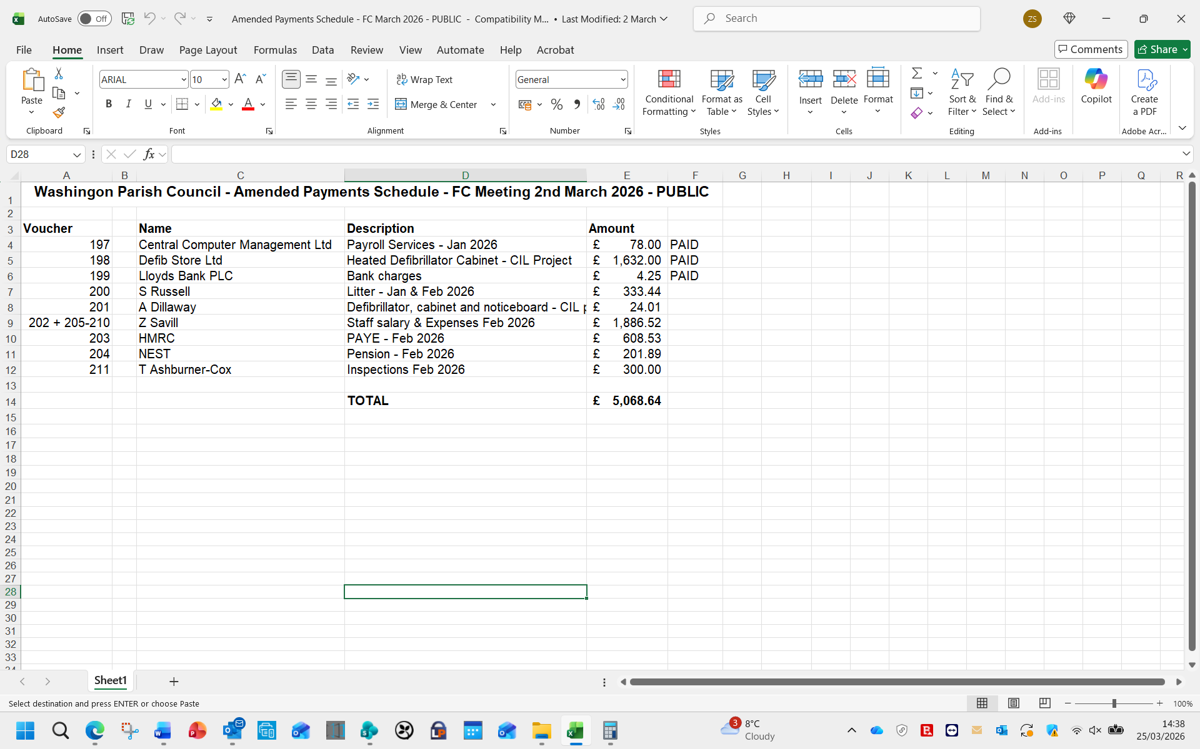

Appendix F
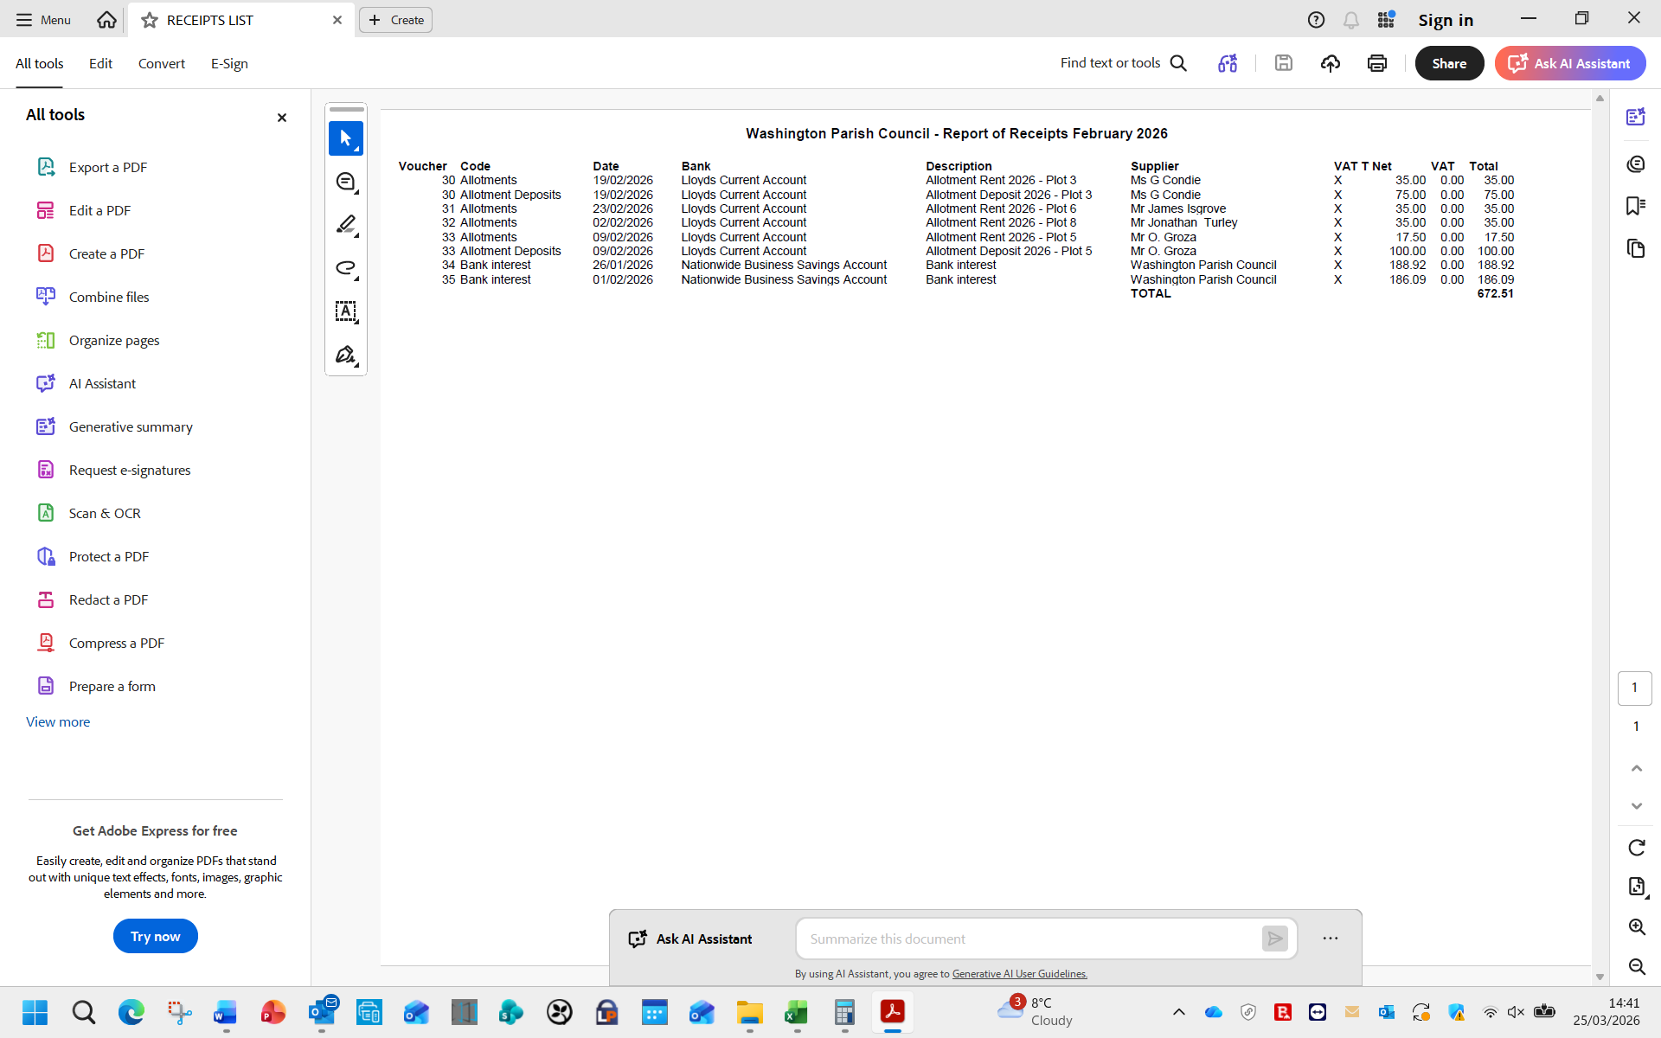

Appendix G
